GitHub setup & file sharing & commit

Created by Linfeng Wu, updated on 08/19/2023

Instructions for GitHub setup & file sharing & commit.

Note: This SOP illustrates how to use GitHub desktop to set up a repository, share files and commit changes. The steps will start from that you’ve already created the Unity project on your computer.

Downloads:

GitHub desktop application: <https://desktop.github.com/>

Steps:

1. GitHub and repository setup.

* Create a GitHub account (not necessary if you already have one): <https://github.com/join>
* Download the GitHub desktop application and install it to your computer: <https://desktop.github.com/>
* Open GitHub desktop application, go to File -> Add local repository, click **Choose** button and navigate to the Unity project folder via your Windows file directory. Click Add repository after the path is set.

* Now you have successfully set your Unity project as a repository via GitHub.

1. File sharing via GitHub.

* Open GitHub desktop application, go to Current repository, right click and choose View on GitHub. This will lead you to open the repository via your web browser.



* After you signed in with the same GitHub account, go to Settings -> Collaborators -> Manage access, and click the **Add people** button to add collaborators to share project files.

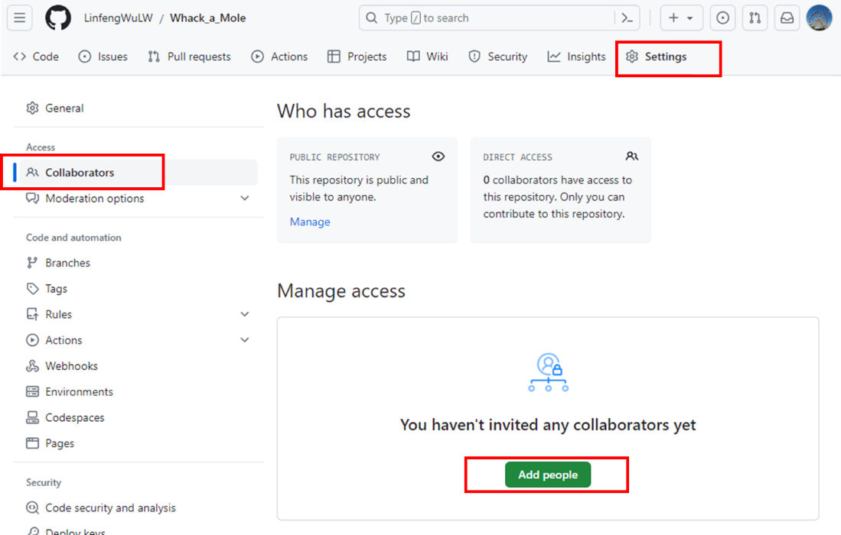

* After other collaborators have access to the repository, they can open the repository via web browser. Go to Code -> Open with GitHub Desktop, to clone the repository to their computer.

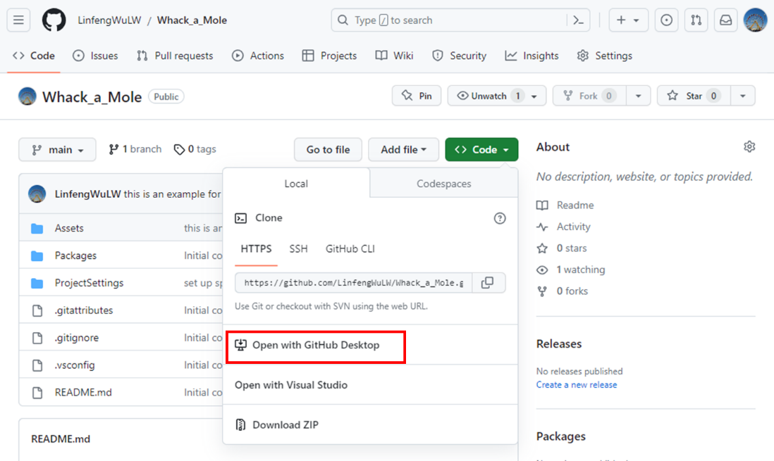

1. Commit changes and Push origin.

* After you make changes to your Unity project, in the GitHub desktop application, all the changes will be detected and show in the **Changes** tab. You can write a summary and description for the changes, and click the **Commit to main** button to commit the changes to the main branch.

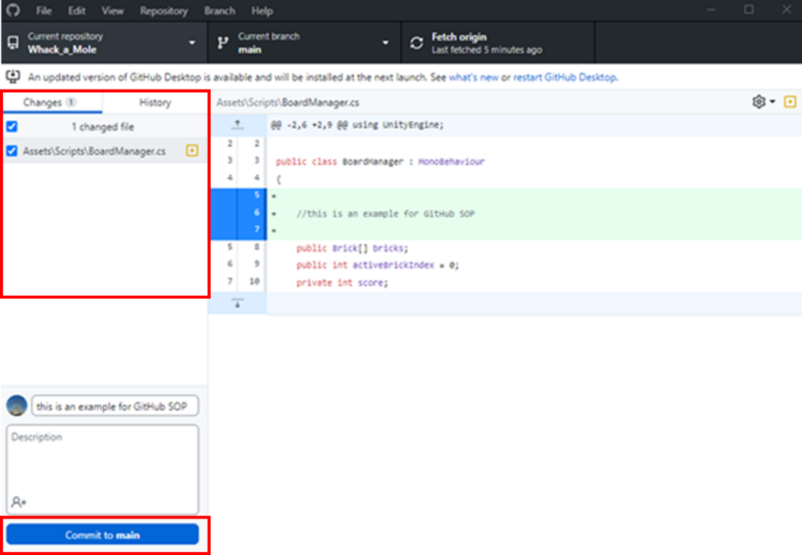

* After you commit the changes, it will show up at the History tab. If it is ready to share with all the collaborators, then you can click the **Push origin** button to push the commit to the repository.

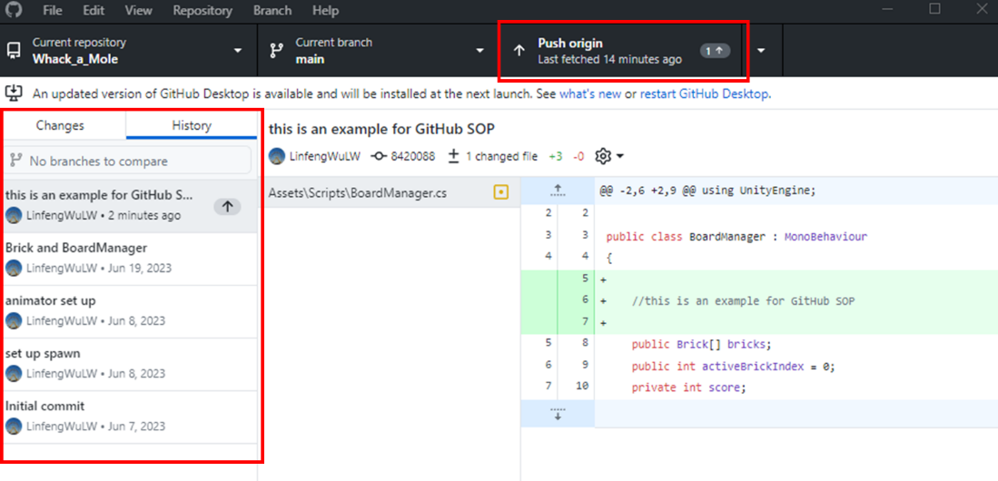

* When other collaborators open the GitHub desktop application from their end, the commit will show up at the **Fetch origin** tab, and they can click it to pull the changes to their local Unity project.

